**Virtual Environment Control System through Sensor Network for Greenhouse**

**A thesis by**

**GHMDD Lakshan**

**IT/13/241**

**Supervised by**

**Mr. B. Hettige**

**Submitted in partial fulfillment of the requirements for the award of BSc (Hons) in Information Technology Degre**

**GENERAL SIR JOHN KOTELAWALA DEFENCE UNIVERSITY**

**2016**

# AUTHOR’S DECLARATION

This thesis contains no material which has been accepted for the award of any other degree or diploma in any University or equivalent institution, and that to the best of my knowledge and belief, contains no material previously submitted or written by any other person , except where due reference is made in the text of this thesis.

I carried out the work described in this dissertation under the supervision of Supervisor’s Name

Signature :

Name of the Student :

Registration No :

…………………………………………………………………………………………

…………………………………………………………………………………………

…………………………………………………………………………………………

…………………………………………………………………………………………

…………………………………………………………………………………………

…………………………………………………………………………………………

Signature Name of Supervisor :

**ACKNOWLEDGEMENT**

I have taken effort in this project. However, it would not have been possible without the generous support and help of many individuals who were there throughout the development. I would like to extend my sincere thanks to all of them.

Finally I acknowledge Professor Mr. B. Hettige and Mr. D Maithri Ranga Kulasekara for encouraging me to write this paper, and also the lecturers who inspire me to write this. The author bears all the responsibility for any misunderstandings and/or errors therein.

# ABSTRACT

In cutting-edge greenhouses, numerous measurement points are required to trace down the local climate parameters in specific elements of the massive greenhouse to make the greenhouse automation system work well. Cabling would make the dimension machine highly-priced and susceptible. Furthermore, the cabled measurement factors are difficult to relocate as soon as they're established. Thus, a wireless Sensor community (WSN) along with small-size sensor nodes geared up with radio one or several sensors, is an appealing and fee-efficient choice to build the required dimension machine. . For every local station a percent Microcontroller is employed to store the instant values of the environmental parameters, send them to the standalone application and receive the control alerts that square measure wished for the operation of the actuators. The communique among the Standalone application and between sensors is executed thru Radio Frequency Module (RFC).Sensor community may be taken into consideration as one of the most important fields that empowers with the approaching new era. The intention of this paper is to present a singular wireless sensor community based monitoring and controlling greenhouse weather. in this Article, we evolved a wireless sensor node for greenhouse monitoring by way of integrating a sensor platform provided via Sensor node with three sensors degree three environment variables This system control the environment parameters according to the environment behaviors.

# TABLE OF CONTENT

AUTHOR’S DECLARATION 2

ABSTRACT 4

TABLE OF CONTENT 5

LIST OF FIGURES 9

LIST OF TABLE 11

Chapter 1 12

Introduction 12

1.1 Prolegomena 12

1.1 Background and motivation 13

1.2 Problem 13

1.3 Solution 13

1.4 Hypothesis 14

1.4 Aim 14

1.5 Objectives 14

1.6 Summary 14

Chapter 2 15

Literature Review 15

2.1 Introduction 15

2.2 Greenhouse Monitoring with Wireless Sensor Network 15

2.3 Analysis of Similar Existing System for Greenhouse 15

2.4 Green house environment 16

2.5 Sensors 17

2.6 Comparison of technology in sensor network 18

2.6.1 The Use of ZigBee Wireless Network 18

2.6.2 Wireless Sensor System 20

2.7 System architecture 22

2.8 Communication Module 24

2.8.1 ZigBee standard 24

2.8.2 XBee Modules 24

2.9 Drawbacks of existing System 25

2.10 Summary 26

Chapter 3 27

Approach 27

3.1 Introduction 27

3.1 Methodology and approach 27

3.2 Functional requirements 28

3.3 Non Functional requirements 28

3.4 input 28

3.5 Process 29

3.6 Output 29

3.7 Summary 30

Chapter 4 31

Analysis and Design 31

4.1 Introduction 31

4.2 The general structure of the system 31

4.2 Network Architecture Design 32

4.3 Sensor node module design 32

4.4 The Design of controlling center 33

4.5 Communication module design 34

4.6 Circuit Diagram Design 35

4.7 Model of Proposed System 36

4.8 Interface Design 40

4.8.1 Standalone Application 40

4.8.2 Mobile Application 42

4.9 Summary 42

Chapter 5 43

Technology and Development 43

5.1 Introduction 43

5.2 Software Development 43

5.1.1Programming Language Selection 44

3.4 Technical Specification 44

5.2 Hardware Development 44

5.2.1 Hardware Devices 45

5.3 System overview 49

5.4 Summary 51

Chapter 6 52

Implementation & Testing 52

6.1 Introduction 52

6.2 Program Development 52

6.3 Implementation plan 53

6.3.1 Implementation tasks 53

6.4 System installation 53

6.4.1 Data conversion 54

6.4.2 User training 54

6.5 Security and privacy 54

6.6 Implementation support 54

6.7 Testing 55

6.8 Summary 56

Chapter 7 57

Evaluation 57

7.1 Introduction 57

7.2 Evaluation on the Project Development Process 57

7.2.1 Analysis Phase 57

7.2.1.1Practices of analysis stage 57

7.2.2 Design phase 58

7.2.3 Implementation phase 58

7.3 Product evaluation 59

7.3.1 Methods of product evaluation 59

7.3.2 Evaluation Criteria 59

7.3.3 Problems which covers by the solution 59

7.4 Project Achievement 60

7.4.1 Project Aim 60

7.3.2 Project Objectives 60

7.4Summary 60

8.0 Conclusion 62

10.0 Reference 63

Appendix 65

# LIST OF FIGURES

Figure 1: Sensor node’s Micro.2420 U100 17

Figure 2: Local wireless station 20

Figure 3: System architecture 21

Figure 4: ZigBee based wireless local station 22

Figure 5:System Architecture 23

Figure 6: XBee Series 2 Radio 25

Figure 7: The system structure of Greenhouse WSN measurement and control 31

Figure 8: Sensor node block Diagram 33

Figure 9:RF Module 34

Figure 10:GSM Module 34

Figure 11:Circuit Diagaram 35

Figure 12: Flow chart of the overall system 36

Figure 13:Use Case Diagram 37

Figure 14:Activity Diagram 38

Figure 15:Block diagram of the system 39

Figure 16:Login Window 40

Figure 17: Interface of the application 41

Figure 18: Mobile Application interface 42

Figure 19: Microcontroller (Arduino Board) 45

Figure 20: GSM Module 46

Figure 21: Temperature sensor & Humidity Sensor 46

Figure 22: Light Sensor 47

Figure 23:LCD Disply 48

Figure 24: System Overview 49

Figure 25: System overview on rich picture 50

Figure 26:Login Window 65

Figure 27:Main interface 65

Figure 28: Auto manual Panel 66

Figure 29: Control Panel 66

Figure 30:Details Panel 67

Figure 31:Login window of mobile application 67

Figure 32: Control Window 68

# 

# LIST OF TABLE

Table 1: Comparison between Wireless Technologies………………………………………….18

Table 2: Testing techniques…………………………………………………………………......44

# Chapter 1

# Introduction

## 1.1 Prolegomena

Greenhouse is a building or place that plants are grown. Greenhouses play an important part of the agriculture and sectors of a country. Greenhouses are used for Grow flowers, vegetables, fruits, and tobacco plant. It create the good and best condition for the plant growth and avoid the effect on plant growth due to some internal or outside environment behaviors changes .Therefor greenhouse helps to maintain the Environmental parameters. Basic factors that affect for plant growth are humidity, light, and temperature etc. The most important factors for the quality and productivity of plant growth are temperature, humidity, light. Greenhouse is a kind of place which can change plant growth environment, create the best conditions for plant growth, and avoid influence on plant growth due to bad environment changes and severe weather. For greenhouse measurement and control system, in order to increase the harvest, improve quality of the product, govern the growth period and improve the economic efficiency and productivity, the optimum condition of crop growth is obtained on the basis of taking full use of natural resources by changing greenhouse environment factors as example temperature, humidity, light. Greenhouse monitoring and control system is a complex system. It needs to various parameters to be controlled .In greenhouse, Environment parameters needs automatic monitoring, information processing, real- time control and online optimization. The development of greenhouse monitoring and control system is a vital part of developed countries to reach their agricultural purposes. But if we introduce the foreign existing systems, the price is very expensive and maintenance will be trouble and inconvenience.

## 1.1 Background and motivation

Till now our agricultural systems are followed by conventional method and manual system are used to control and monitor environment in the Green house whereas developed countries use automated system to control their agricultural economy to grow more products than before using same lands and weathers, though Moderate and flexible weather condition always helps us to grow different plants at different seasons and under various environment. But it is harder to do it manually because always our attention must be focused on it. The optimal greenhouse environment adjustment can enable us to improve productivity and to enhance the cultivation when environment parameters change rapidly. This system is used to monitor and control the essential greenhouse parameters, such as, Temperature, humidity and light intensity. Automated greenhouse involves the automatic monitoring and controlling of climatic parameters which directly or indirectly govern the plant growth and their production. In order to control the environment factors and environment autonomously, it is required an automated computer/software equipment. The system has advantages of low power consumption, low cost, good robustness, and extended flexibility.

## 1.2 Problem

Environment factors like temperature, humidity and light are hard to control manually inside a Greenhouse. There is a need for automated system to do that task. When Environment behaviors change rapidly, immediately response must be activated. It can’t be done by the manual system. As well as manual system’s price is very expensive and maintenance isn’t convenient.

## 1.3 Solution

Build an Automated virtual environment control system through sensor network to control the environment parameters that rapidly change. This automated system involve the controlling of environment parameters which directly or indirectly govern the plant growth and their production. For greenhouse, environment control system increase crop yield, improve quality, regulate the growth period and improve the economic efficiency, and the optimum condition of crop growth by changing greenhouse environment factors such as temperature, humidity, light etc. This system can be used to grow plant under controlled climatic condition for optimal production. In order to control the environment parameters software application will be created.

## 1.4 Hypothesis

The system will integrate with Arduino technology and Sensor network to capture tee environment parameters. Using standalone c# application and android application will control the environment parameters manually and automatically.

## 1.4 Aim

The aim of this project is to build efficient and effective automated system to control the environment parameters that change rapidly.

## 1.5 Objectives

* Build best greenhouse which is equipped with automatic monitoring and controlling system
* Constantly monitor and control environmental condition in green house to ensure it at preset temperature light and humidity level.
* The user can see atmosphere condition of the greenhouse plant on standalone application and mobile application and control the green house from far away places
* Minimizes labor costs involved in maintaining a greenhouse
* Detect and maintain temperatures
* Detect and maintain humidity levels
* Detect sunlight and artificial light.

## 1.6 Summary

This chapter is basically discussed about the background of the problem situation and scope of the proposed solution. Although this chapter has discussed about overall idea of the system development. Scope of the proposed system. Next chapter will go through existing systems to identify available technologies and key research areas.

# Chapter 2

# Literature Review

## 2.1 Introduction

Greenhouse is a building or place where plants are grown. Greenhouses form an important part of the agriculture sectors of a country. Greenhouses are used for Grow flowers, vegetables, fruits, and tobacco plant. It create the best condition for the plant growth and eliminate the impact on plant growth due to some outside environment behaviors changes.

## 2.2 Greenhouse Monitoring with Wireless Sensor Network

Teemu Ahonen, Reino Virrankoski and Mohammed Elmusrati have done research in green house monitoring at the University of Vaasa in Finland. They made their experiments in Martens Greenhouse. They have developed wireless sensor node for greenhouse monitoring by integrating a sensor platform to control the temperature humidity and CO2vof the environment. With three commercial sensors capable to measure four environment variables. The feasibility of the developed sensor node was tested by deploying a simple wireless sensor network into Martens Greenhouse Research Foundation’s greenhouse in Närpiö town in Western Finland. During a one day experiment, they collected data to evaluate the network reliability and its ability to detect the microclimate layers, which typically exist in the greenhouse between lower and upper flora. They were also able to show that the network can detect the local differences in the greenhouse climate caused by various disturbances, such as direct sunshine near the greenhouse walls. This project can set the reference values to certain environmental variables, and then the greenhouse automation system targets to keep the variables in these environment values. The optimal levels of water and fertilizer can also be defined.

## 2.3 Analysis of Similar Existing System for Greenhouse

M. Mancuso and F. Bustaffa have done research work in Wireless Sensors Network for Monitoring Environmental Variables in a Tomato Greenhouse. The Rinnovando group (Rgroup) is working with agricultural experts on small deployment of a wireless sensors network in a tomato greenhouse in the South of Italy. In this project, Sensicast devices are used in order to apply of Sensor Networks (WSN) in agriculture and particularly that of environment monitoring within a greenhouse incorporating sensor nodes in an agricultural ICT infrastructure. They have used sensor node for the air temperature, humidity and soil temperature measurements light with wireless sensor network. They have also developed a Web-based application to monitor the plant. Sensor node can read the measurements over the Internet, and notification will be sent to his mobile phone by SMS or GPRS if some measurement variable changes rapidly. They have developed and implement a WSN prototype for environmental monitoring and control inside the greenhouse. They are using a star topology network and tree topology of Crossbow MICAz motes. The motes measure, humidity, temperature and soil moisture, and send their measurements to the sink node in five minutes intervals. Sink node is a combination of MICAz mote and MIB510 board with data terminal. The terminal with ARM processor module shows the latest measurements and view in LCD-screen inside the greenhouse and delivers the data to the main PC by using GSM module. The central PC located further apart from the network takes care of data logging and processing.

## 2.4 Green house environment

When considfer Martens Greenhouse Research Center’s greenhouse in the Närpiö town in Western Finland .The size of the greenhouse was 18 x 80 meters and in its traditional control system it has only wired cable measurement unit in the middle. Greenhouse’s moist environment and dense flora are similar to the surroundings of a jungle. This kind of environment is challenging both for the sensors,electronics and for the short-range IEEE 802.15.4 wireless network, which communication range is much longer in open areas. Therefore, we limited the distances between communicating nodes to 15 meters in our deployment.

The wireless sensor they used was Sensinode’s Micro.2420 U100 . It operated as a basic measuring node with a CC2420 802.15.4 RF-transceiver and a MSP430 Microcontroller. The gateway node was a combination of U100 node and USB serial adapter board (Micro.USB U600). Sensors were soldered to a board equipped with the needed components (resistors, capacitorsand operation amplifier). Then the sensor board fas plugged in to the U100 node through its I/O pins. The node and two 1,5V AA-batteries acting as power source were sheltered by a plastic box (80*55*33mm) to prevent them from the humidity,temperature humidity and light. Sensor board was placed on the top of the box and sensitive electrical components were protected from the moisture by a plastic coating spray. Whole board was enveloped by ESD plastic sachet leaving only the heads of the sensors outside.

Sensor node’s devices are based on 6LoWPAN protocol, which enables transmission of compressed Internet Protocol version (IPv6) packets over IEEE 802.15.4 networks .Sensinode’s Nanostack protocol provides the use of 6LoWPAN and a standard Socket API for accessing the sensor network. It works in 2,4GHz ISM band and offers 250 kbps data rate.

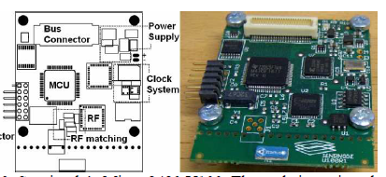

Figure 1: Sensor node’s Micro.2420 U100

## 2.5 Sensors

Fast response time, tolerance and low power consumption and against moisture climate made SHT75 relative humidity and temperature sensor a perfect solution for the greenhouse environment. Temperature accuracy and correctness of the sensor is ±0.3 °C and the accuracy of the relative humidity under 2 %. Communication between SHT75 sensor and node is similar to IIC interface developed by Philips and Samsung. Data and clock line are the same in both scenarios, but SHT75 has only one pull-up resistor between data and power supply line. Luminosity was measured by TAOS TSL262R that converts light intensity and strength to voltage. Unstable output signal is handled by low-pass filter to get correct and accurate luminosity values. We mounted irradiance, humidity and temperature sensors into four nodes, but Carbon dioxide sensor was tricky because it needs special requirements for the input voltage and the response time. Figaro’s TGS4161 carbon dioxide sensor was the alternative that was the most compatible with low voltage sensor node.

In this system four nodes were deployed to one greenhouse environment to gather information about the differences in environment variables between lower and upper flora. Each node red temperature, irradiance and humidity and values once in four minute intervals over three hours. During the experiment, the coordinator sent 200 data requests, and each sensor node responded 50 times. Ten packets with readings were either received incorrectly or lost .That indicated 5% data loss rate in terms of packets. The maximal communication range, 15 meters was identified in individual test where the distance between the control center and the sensor node inside the greenhouse dense flora was increased until the connection was lost. We also observed that the correct and accurate range in terms of tolerable packet loss was approximately 10 meters. Compared to previous experiment in an open parking lot, the reliable communication range fell to one third in the greenhouse’s dense flora.

## 2.6 Comparison of technology in sensor network

### 2.6.1 The Use of ZigBee Wireless Network

Ibrahim Al-Adwan, Munaf S. N. Al-D have done research in The Use of ZigBee Wireless Network for Monitoring and Controlling Greenhouse Climate. The aim of this paper is to present a novel wireless sensor network based ZigBee technology for monitoring and controlling greenhouse environment. The system consists of a number of local stations. Base station and a central station. The local stations and base station are used to measure the environmental parameters and to control the operation of controlled actuators to maintain environment parameters at predefined set points. For each local station a PIC Microcontroller is used to store the instant environment values of the environmental parameters, send them to the central station, control center and receive the control signals which are required for the operation of the actuators. The communication between the local stations and the central station is achieved via ZigBee wireless modules

This control system for the greenhouse includes the following components.Data acquisition of the environmental parameters through sensors. The processing of data, comparing it with desired states, and finally deciding what must be done to change the state of the system. The actuation component carrying the necessary actions. The control of the greenhouse investigated in this paper consists of several distributed local stations and one central station. Each local station is responsible for obtaining the greenhouse climate parameters by three sensors for the temperature, humidity and light. These sensors are connected to a PIC16F877A microcontroller which consists of embedded ADCs. A ZigBee transceiver is directly connected to the microcontroller to supply a wireless connection with a control center. A PC was used to implement the central station at which the set value for each environment parameter is declared and compared to those received from each base station. Based on the measure and set values of the parameters the central station provides the required control action at each location. These control actions are sent back to the base stations via ZigBee module. Finally, when the control actions received by the base station, the microcontroller will provide the necessary control signals to the actuators and coordinate their operation. Figure 2, shows the schematic diagram of a local station, and figure 3 shows a block diagram for the system architecture.



Figure 2: Local wireless station

### 2.6.2 Wireless Sensor System

Sensors supply input information for the automation system by measuring the climate variables of the greenhouse. Sensor-generated signals are acquired and conditioned by a PIC16F877A microcontroller. Three parameters are monitored in this study namely temperature, humidity and light or solar radiation

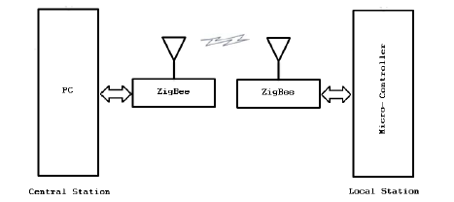

Figure 3: System architecture

In this project, thermistors are used to measure the temperature in the greenhouse. Thermistors are temperature dependent resistor devices, they are easier to wire, cost less and almost all automation panels accept them directly. Thermistors are made of semiconductor materials with a resistivity that is especially sensitive to temperature. When it comes to humidity sensing technology, there are three types of humidity sensors they are capacitive, resistive and thermal conductivity humidity sensors. They used Capacitive Humidity Sensors (CHSs) which are widely used in industrial, weather commercial and telemetry applications. CHSs consist of a substrate on which a thin film of polymer or metal oxide is deposited between two conductive electrodes. The sensing space is coated with a porous metal electrode to protect it from contamination and exposure to condensation. The substrate is typically glass, ceramic, or silicon. The changes in the dielectric constant of a CHS are nearly similar to the relative humidity of the environment. CHS are able to function in high temperature environments (up to 200°C), near linear voltage output, wide Relative Humidity range, high condensation tolerance, reasonable resistance to chemical vapors and contaminants, minimal long-term drift, high accuracy, high correctness small size and low cost.

This project show some of the popular light sensors on the market that can be used for environmental monitoring and controlling applications. Here, Light Dependent Resistor (LDR) Similar to photometric sensors, LDRs measure and identify visible light as seen by the human eye. A LDR is basically a resistor the internal resistance increases or decreases dependent on the level of light intensity impinging on the surface of the sensor.Finally, a greenhouse sensor station has been designed and fabricated which is part of a complete greenhouse management system. The local station takes charge of collecting climate measurements data in a greenhouse (temperature, humidity and light) and transmits the data to the central station.

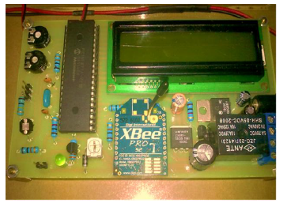

Figure 4: ZigBee based wireless local station

Rana H. Hussain, Dr. Ali F. Marhoona and Dr. Mofeed T. Rashid have done research on Wireless Monitor and Control System for Greenhouse This paper involve a design and implementation of an XBee based Wireless Sensor Network (WSN) which is used to monitor and control the essential greenhouse environment parameters, such as, temperature, humidity and light intensity. This project supports the farmers to increase the crop production and it provide the productivity of the crop. The standalone XBee module, i.e., without microcontroller, is integrated with specific small size sensors. All monitored environment parameters are transmitted through a wireless link to computer via coordinator to be analyzed, and then initiate suitable commands to the specific gadet to overcome the drifts in an environmental parameters inside greenhouse.

## 2.7 System architecture

When considering the architecture of this system is shown in Fig.1 which composed of two types of physical units: three remote sensor nodes, and a central control station. The remote sensor nodes are created with an XBee radio and analog sensors. These radios can work with ZigBee topologies which are set up to read analog signals directly from sensors to be transferred with in a data packet. Each node is enabled to read humidity, temperature, and light levels. The measured data are sent periodically to the control center. The central control unit consists of XBee radio kit that connected to personal computer through USB.

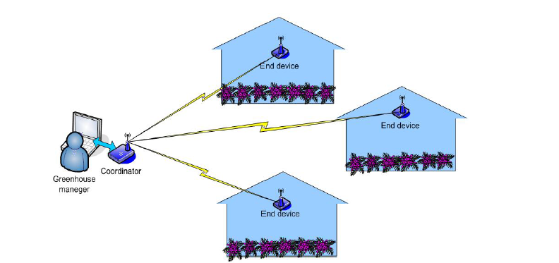

Figure 5:System Architecture

XBee is a device that used to send and receive data wirelessly base on ZigBee/IEEE 802.15.4 network standard.XBee could be set up to operate in different function including the End Device, Coordinator, Router and.There are several types of XBee module, the very famous XBee is Series 1 (802.15.4), and series 2 that operate on ZigBee protocol. Each XBee radio has the capability to directly collect and transfer sensor data if it is configured as end device. XBee s2 is selected to be used as standalone device for gathering analog signals from three different sensors. In addition to the ability of this XBees2 to initiate the control signals though it's digital output bits. Hence, there is no need to use any microcontroller to do (I/O) operation.avoiding the external microcontroller means saving and storing money for sensor networks with hundreds of nodes, also the power consumption and node size will be minimized.

## 2.8 Communication Module

### 2.8.1 ZigBee standard

There are different types of wireless communication technologies such as Wi-Fi, ZigBee and Bluetooth. All these types are work in same RF frequencies, and their application sometimes overlap for example can be used in greenhouse environment. In this project, ZigBee technology has been used because there are many advantages of this technology than the others technologies because it has following aspects. Reliable and self-configuration, Supports large number of sensor nodes, easy to develop and deploy, it has very long battery life, Secure and Low cost. Table 1 represents a comparison between these standards.

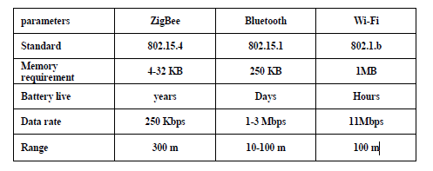

Table 1: Comparison between Wireless Technologies

### 2.8.2 XBee Modules

XBee is the kind of a brand name from Digi International for a family of form factor compatible radio modules. The first XBee radios were introduced under the MaxStream .They were based on the 802.15.4 standard designed for point-to-multipoint and point-to-point and communications at over-the-air baud rates of 250 Kbps. Two models were initially introduced a lower cost 1 mW XBee (S1 and S2) and the higher power 100 mW XBee-PRO.

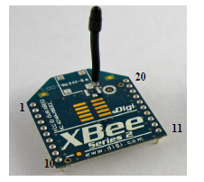

Figure 6: XBee Series 2 Radio

## 2.9 Drawbacks of existing System

Ashenafi Lambebo and Sasan Haghani have done research on A Wireless Sensor Network for Environmental controlling of Greenhouse Gases. This project provides and supply a detailed study and implementation and configuration of a WSN for real time and continuous environmental monitoring and controlling of greenhouse gases. A tree-topology WSN consisting of three sensor nodes and a base station was successfully built and tested using inexpensive and open source hardware to measure and control the concentration level of several greenhouse gases. The sensor nodes consisted of carbon monoxide sensor, humidity sensor carbon dioxide sensor, a methane sensor, a temperature sensor, a GPS module and a ZigBee wireless transmitter packaged together. The GPS module was added to provide information about the location of the all sensors. The base stations consisted of an Arduino Uno micro-controller and a ZigBee/Xbee module receiver that can collect data from the various sensors and analyses that data and submit to a sink base station where data can be stored and processed. A website was developed where the captured data can be continuously monitored, controlled and displayed in real time.

When taking about the network architecture The Wireless Sensor Network (WSN) was implemented using a tree topology in beacon mode where sensors collect data and send it to the base station which is the task manager of the network. The proposed WSN architecture is shown in Fig. 7.Two individual environmental sensor nodes serving as transmitters have been designed to collect, process, and transfer the gas concentration levels, temperature, and the sensor’s location signals in actual time. The system operates and maintain within a range of 100m or 150m from the base station and it is suitable for monitoring and controlling the concentration of greenhouse gases inside industrial buildings and warehouses. The base station, which is the network coordinator and controller, manages the activities of individual nodes by periodically requesting data. In addition to data integration and analysis The Base station also relays processed data to display,PDAs and devices. The base station is work with an Arduino Uno Microcontroller for system coordination and configuration, a receiving a Wi-Fi_33 module and ZigBee module and for wireless communication and data transmission over the 802.11b/g wireless networks, which make it is able to access the collected data via the Internet. In addition, the captured data is stored into a MySQL database where a webpage with a graphing application Programming interface (API) is used to display and view the data.

## 2.10 Summary

In this chapter a study on existing systems has been done. This chapter also contains

a comparison between similar systems in order to identify the most optimum method to be used in the proposed system development. Next chapter will discussed about technologies to be used in details.

# Chapter 3

# Approach

## 3.1 Introduction

This chapter will describe about the technology used in developing the Virtual environment control system. This chapter will filled with how researcher solved the problem with using available technologies in detail. Furthermore, this chapter will discuss about hypothesis, inputs, process, outputs, users and features of the system development. Although this chapter is dedicated to discuss the software development and hardware development of virtual environment control system from the technological perspective. It is discussed about the technologies considered when developing the solution and the factors considered when choosing the technologies. Furthermore technical and usability requirements are also mentioned in this chapter.

## 3.1 Methodology and approach

This system is used to monitor and control the essential greenhouse parameters, such as, Temperature, humidity and light intensity. Automated greenhouse involves the automatic monitoring and controlling of environment parameters which directly or indirectly govern the plant growth and their production. In order to control the climate factors and environment autonomously, it is required a computer/software equipment. The system has advantages of low power consumption, low cost, good robustness, and extended flexibility. Environment factors like temperature, humidity and light are hard to control manually inside a Greenhouse and there is a need for automated system to do that task. When Environment behaviors change rapidly, immediately response must be activated. It can’t be done by the manual system. As well as manual system’s price is very expensive and maintenance isn’t convenient. The purpose system would be based on the sensor network technology and this purpose system will be developed using the android and C# standalone application. The sensors will be connected to the microcontroller board and that main system will be connected to the c# standalone application and the android application.n.RFC module will be connected to the PC and that RFC module will be wirelessly connected to the sensor network

Temperature, humidity and Light sensor capture the environment parameters and that parameter values show on the standalone application Furthermore there is a graph to show the behavior of the environment parameters. At the beginning we set the fix value on the standalone application and if that values exceed the environment parameters automatically output devices will be activated. Therefore at the beginning a brief study on the previous projects done in the sensor network, Network was connected weirdly.

## 3.2 Functional requirements

* This system should automatically control environment condition with in green house allowing any type of plant to be grown.
* This system should capture the environment parameters like temperature, Humidity and light.
* This system should minimize labor cost involved in maintaining greenhouse.
* System should eliminate risk of greenhouse not being maintained at specific environment condition due to the human errors.
* System should automatically send SMS to the user when environment parameters changes
* System should be controlled manually using android application and the standalone c# application

## 3.3 Non Functional requirements

* System should possess a non-complex user friendly
* System should be reliable
* System should be secured
* System should be efficient and provide quick feed back

## **3.4 input**

In this project, a wireless sensor network will be developed for greenhouse monitoring by integrating a sensor node. There are three sensors capable to measure four climate variables. They are temperature sensor, humidity sensor and light sensor. Temperature sensor capture the temperature. Humidity sensor capture the humidity level of the environment and the light sensor capture the light level of the environment. That parameters can be view as the input of the purposed project

## **3.5 Process**

Sensor node capture the environment variables. There are 3 sensors at input side and it has 3 devices at the output side to control the respective parameter. There is a Standalon application develop with C#.That C# application input the values that must be have in the greenhouse. Sensor node capture the environment variable like temperature, humidity and light. If environment variable captured by sensor network greater than value that enter by web application, devices will be automatically activated (Fan, Light and Exhaust Fan) at the output side and send SMS notification to the User. All output devices will be connected wirelessly to the gateway. They can communicate wirelessly.

## 3.6 Output

Based on input values, devices will be switched OFF/ON automatically.

* If the temperature exceeds beyond the limit set then a fan will be automatically switched ON as a coolant to reduce the temperature
* Humidity sensor is used to check the humidity of the air in the greenhouse. If the humidity exceeds the limit set then an exhaust fan will be switched ON to maintain the suitable environment for the plants
* Light sensor sense the light and set an optimum light in the greenhouse for the plants. An artificial light will be switched ON automatically by the light sensor if there is insufficient light for the plants in the greenhouse .And the light is switched OFF automatically when the plants get sufficient light from the sun
* Alarm will be sent to his mobile phone by SMS, if some measurement variable changes rapidly.

## 3.7 Summary

Technology is a most essential criteria and backbone of a system development project. This chapter has been going through various technologies which can be used in developing the proposed project. Furthermore this chapter discussed about the required resources that need to be considered for the developing system as well as the usability requirements that needs to be considered

# Chapter 4

# Analysis and Design

## 4.1 Introduction

In chapter 4 we have discussed our approach to the project.in there we presented our approach by input, output, process, features etc. So this chapter will be discussed about the analysis of gathered data and will reveal to the designing spectacles of the over roll System the greenhouse measurement and control system contain monitoring center, sensor node and the electrical equipment. Sensors are deployed in the every place in the GrennHouse.The greenhouse environment information send to the control center. The control center analyze these data that has been obtained then relevant decision are taken and send the control message to the greenhouse control equipment that regulate the environment parameters to obtain best growth environment for crops.

## 4.2 The general structure of the system

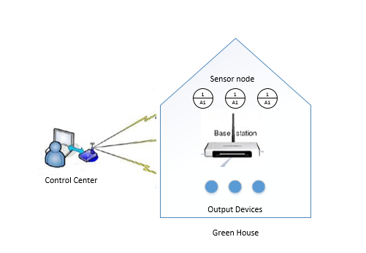

Figure 7: The system structure of Greenhouse WSN measurement and control

According to the above figure, the data collected by the sensors in the greenhouse and that data transferred via wirelessly to a computer for data logging and the correlation. The data is transferred using the radio frequency.

## 4.2 Network Architecture Design

The wireless sensor network was implemented using a tree topology (because data being sent continuously without interruption.) Three nodes with temperature, humidity and light. That sensors measure environment variable and communicate directly with the control center. The control center act as the coordinator and receive the sensor data from the sensor node. That sensor nodes are located within the green house. Figure 16 illustrates how the sensor nodes were deployed in the greenhouse .Sensors collect data and send that data to the base station which is the task manager of the network. The purpose sensor network architecture I shown in figure 16.Three environment sensor nodes are serving as the transmitter to collect data. Process data and send data. The system operate within the 100m from the control center. The sensor network is a computer network that contain with the distributed anonymous devices using sensors to cooperatively monitor the physical and environment condition such as temperature humidity and light.

## 4.3 Sensor node module design

Sensor node are composed of the CPU module, wireless communication module, sensor module, position switch and energy supply module. Sensor node module is responsible for the monitoring environment information collection and the data transfer according to the application requirement and can select temperature sensor, humidity sensor and the light sensor etc. Processor module is responsible for the controlling the sensor node module. Wireless communication module is responsible for wireless communication, exchanging control information and transfer acquisitions data between this nodes and the other nodes. Figure 17 is shown the sensor node block diagram. Data wirelessly send to the control center using sensor nodes for processing, display and storage. To program the microcontroller in the transmitter node, arduino IDE language is used to develop the project. The function of the sensor nodes are summerizez below.

* Collect continuous and real time sensor data from each sensor.
* Process the inputs from each sensor using the corresponding sensor code.
* Transmit the processed data to the base station periodically for further analysis and display.

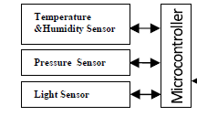

Figure 8: Sensor node block Diagram

## 4.4 The Design of controlling center

The controlling center control the operation of the whole network. As well as it control the measurement and control area in the greenhouse. Standalone application and the base station wirelessly is wirelessly connect to using the Radio Frequency. Control center gather data, analyze data categorize data and comparing data with others .The main function of the control center describe belo

* Network management and control function.

Control center starts the network and stop the network, First we have to configure the port with the base station .After base try to gather environment data using the sensor nodes. When closing the connection, whole network will be lost. To start again the network control center have to configure with the port.

* Analyze the data

Control center analyses the data that gathered and get the correct decision to give the proper output. It check the environment parameter values and it compares the entered value in the application and according to that system will be activated. Figure 18 is shown the flowchart of the overall system.

## 4.5 Communication module design

Control center and the base station communicate wirelessly using the radio frequency module. Sensor node get the environment parameters and that values is sent to the control center wirelessly using Radio frequency’s module is used communicate between the mobile application .It work with the GSM technology. If there is any change in environment automatically SMS send to the Smart Phone. As well as base station can be manually controlled by the Mobile application due to the GSM module

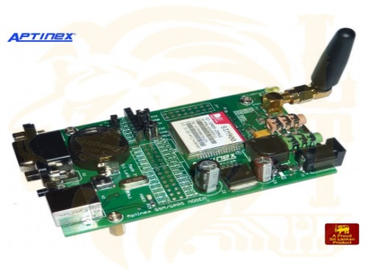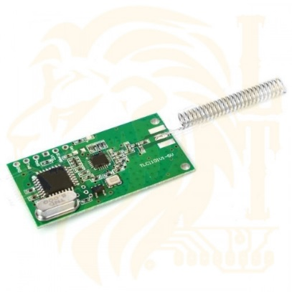

Figure 9:RF Module

Figure 10:GSM Module

## 4.6 Circuit Diagram Design

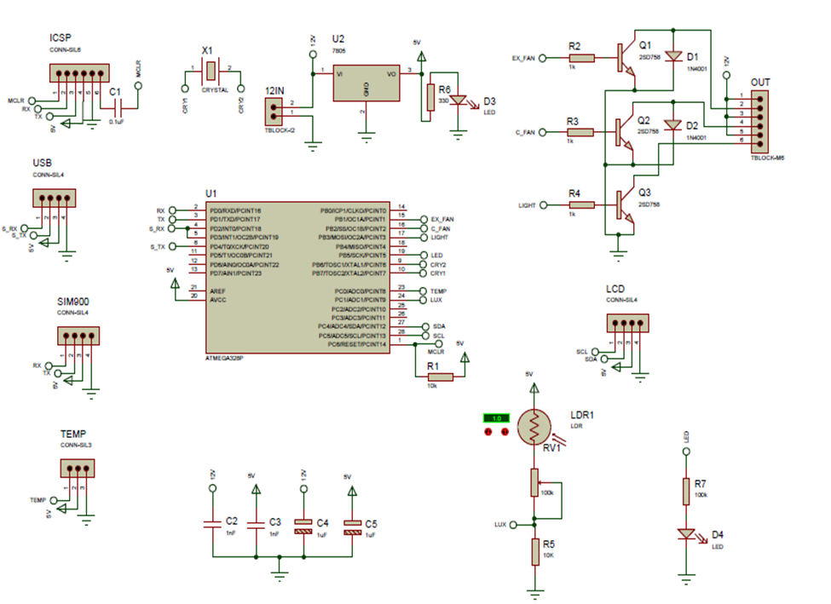

Figure 11:Circuit Diagaram

## 4.7 Model of Proposed System



Figure 12: Flow chart of the overall system



Figure 13:Use Case Diagram

Log on to the System

End

Send SMS to the User and activate the devices

Yes

Execute the control rules

Validate the data with system

Get the environment parameters by sensors

Figure 14:Activity Diagram

No



Figure 15:Block diagram of the system

## 4.8 Interface Design

### 4.8.1 Standalone Application

For use the system everyone must need to login to system by using this window.

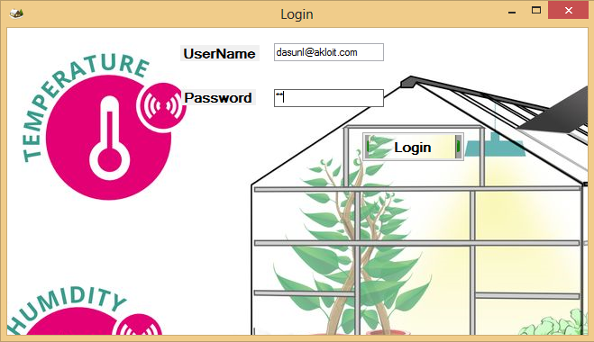

Figure 16:Login Window

In this section, visual studio c# is selected to develop the standalone application used to control and display the data.

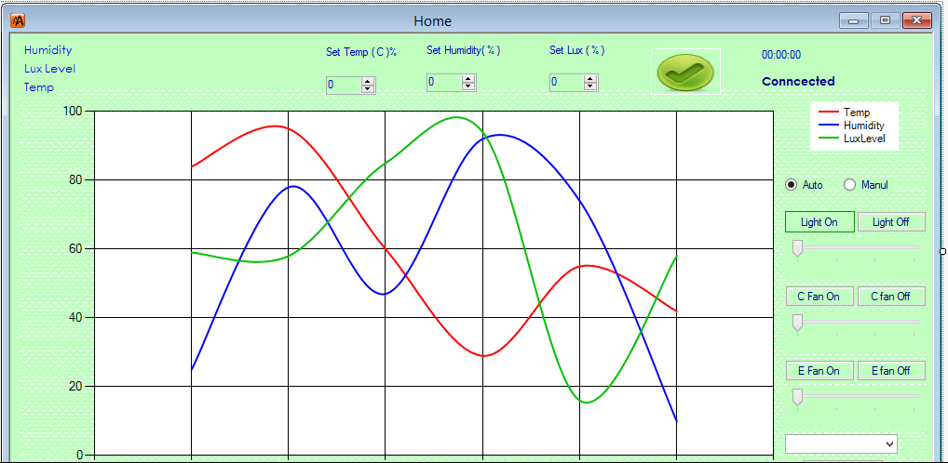

Figure 17: Interface of the application

Using this application, fixed value can be store in the system, this application show the current environment parameter values. As well as using this application we can manually control the output devices such as fan, Light and exhaust fan.

### 4.8.2 Mobile Application

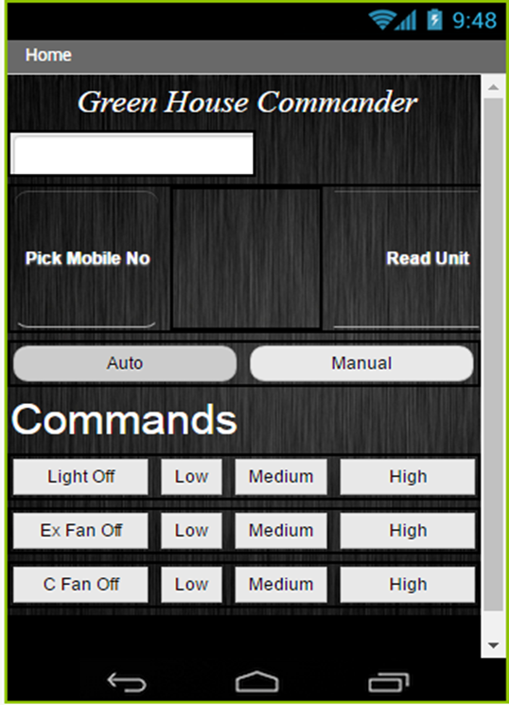

Figure 18: Mobile Application interface

Figure 16 show the mobile application of the system. Mobile application can manually control the output devices such as fan light.

## 4.9 Summary

In chapter 4 we have discussed our approach to the project.in there we presented our approach by input, output, process, features etc. So this chapter discussed about the analysis of gathered data and will reveal to the designing spectacles of the over roll application, further more in this the modules embedded in the application and the interaction among them.

# Chapter 5

# Technology and Development

## 5.1 Introduction

This chapter will describe about the technology used to prove the solution. The design of the proposed system in brief and the implementation done so far and the work to be done in order to complete the project. So in this chapter it hopes to discuss about the technology perspective of the entire software development. It was found that vivid varieties of technologies have been taken into usage when developing those systems. Among those technologies, it has been found that the following technologies are decisive with the project development.

## 5.2 Software Development

It is very essential to use appropriate and standard tools in order to develop a successful system. Use of any inappropriate tools will only leads to develop a system with containing errors and faults, and use of these poorly chosen technologies also will leads to crash the system after it has been deployed. Efficiently chosen technologies which may be highly advanced and complex which allow producing a system with a high quality, but these technologies may also lead to develop a System that use up lots of time and resources in order to perform a task which is expected by the system. Poorly chosen technologies can be outdated, more complex, unfitting for the particular industry, not support to current system, integration problems and may not be achieve all the system functionalities as wanted. Specially, the researcher should think about effectiveness, flexibility, re-usable, performance, and time and cost efficiency, user friendly, attractive development when take decisions about technologies for the development. For the mention factors it must use the most appropriate tools available in the market to develop the system. When go through all of these points, technology selection is the major task of a software development.

### 5.1.1Programming Language Selection

The programming language that is going to use as the developing language for the system development was greatly depended on accuracy and efficiency. This system is mainly based on the Microsoft visual studio C# ,Arduino IDE and android technology. By using Microsoft visual studio C# and android technology, it will reduce extra cost that need to be bared for purchasing some components and tools. Because Microsoft visual studio C# and android are open source and all components are free to use. For development of this system java with Microsoft visual studio platform will be more suitable. C# and android is fully object oriented by design and more flexible in handling. C# and android are used in programming with Microsoft visual studio platform which provides an easier and flexible environment for the programming purposes and GUI developments.so it will be able to reuse the system components in effective manner at a later time. If the platform is going be changed then, no redevelopment will be required for the system. So it will be most benefited for the users if it is intending to change the system requirement in the future.

## 3.4 Technical Specification

The technologies which are used to implement the system are:

* Application will be developed using Microsoft visual studio 2013 (C#),Arduino IDE and Android Studio
* Sensor Node.Ardunino board, RF Module,GSM Module,Fan,Light will be used as a hardware devices

## 5.2 Hardware Development

When selecting the technology the developer must be very concerned about certain facts. If not it may lead to many failure in the middle of the development. Some such factors to be considered are,

* Effectiveness
* Flexibility and Re-Usability
* Performance
* Time and cost efficiency
* User friendly
* Attractive development

## 5.2.1 Hardware Devices

#### 5.2.1.1 Sensor network

Wireless sensor networks (WSNs) has ability to efficiently sense various parameters with high accuracy, correctness and low power consumption. The development of sensors and networks based on sensor nodes has impacted and changed our everyday life. Wireless sensor network (WSN) can form a useful part of the automation system architecture in modern greenhouses .A wireless sensor network (WSN) is a system consisting of a collection of nodes and a base station. Wireless communication can be used to collect the measurements and to communicate between the centralized control and the actuators located to the different parts of the greenhouse.

#### 5.2.1.2Micro controller

The microcontroller is the main part of the proposed embedded system. It constantly monitors the digitized parameters of the various sensors and verifies them with the predefined values and fixed values and checks if any corrective and accurate action is to be taken for the condition at that instant of time. In case such a situation arises, it activates the actuators to perform a controlled operation. Arduino is an open-source electronics prototyping platform/environment. The Arduino is built for designers and artist’s people with little technical expertise

.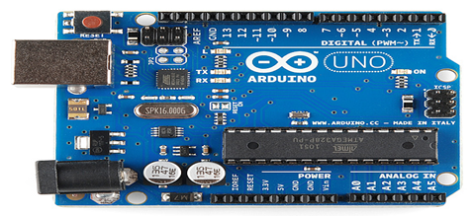

Figure 19: Microcontroller (Arduino Board)

#### 5.2.1.3 GSM Module

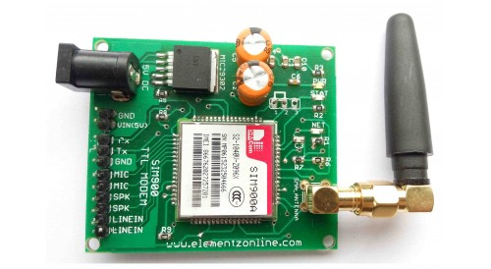

Figure 20: GSM Module

GSM/GPRS module is employed to determine communication between a pc and a GSM-GPRS system. World System for Mobile communication (GSM) is design used for mobile communication in most of the countries. Global Packet Radio Service Radio Service (GPRS) is AN extension of GSM that allows higher knowledge transmission rate.

#### 5.2.1.4 Humidity Sensor

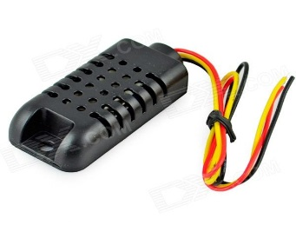

Figure 21: Temperature sensor & Humidity Sensor

A humidity sensor, can be called a hygrometer, measures and regularly reports the relative humidity in the air. Humidity sensor SY-HS-220 can be used to sense the humidity of the air in the green house. If the air is warmer, the more moisture it can hold, so relative humidity changes with fluctuations in temperature. Operating temperature: 5°C to 45°C. Humidity Measurement Range: 5%RH to 95%RH. If the humidity go beyond the maximum limit then the exhaust fan attached with Arduino will be switched ON automatically.

#### 5.2.1.5 Light Sensor

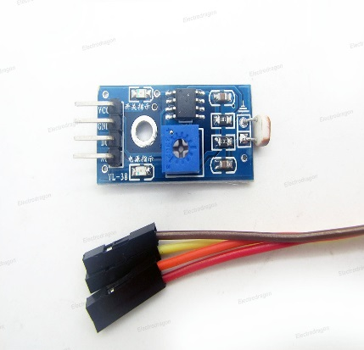

Figure 22: Light Sensor

Light Sensor is a device that is used to detect light. Light sensor is a small sensor that changes its resistance when light shines on it. They are used in many consumer products to determine the intensity of light.

#### 5.2.1.6 LCD Display

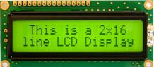

Figure 23:LCD Disply

A LCD is work with arduino at 7th, 6th, 5th, 9th, 3rdand 8th pins to display the reading of various sensors. ‘T’ represents temperature, ’H’ represents Humidity , ‘M’ represents Moisture and ‘L’ represents internal Light intensity of the greenhouse, on the LCD.

#### 5.2.1.7 Other Output Devices

Light Bulb

Light bulb is used to control the light of the environment according to the sensor node

CoolingFan and Exhaust Fan

Fan are used to control environment humidity and temperature according to the sensor node parameters

## 5.3 System overview

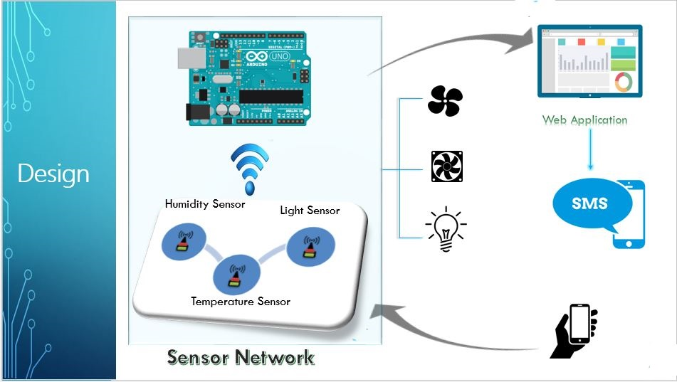

Figure 24: System Overview

**Devices**

Exhaust Fan

Fan

Light Bulb



**If values captured by sensors > Input values by the app**

Temperature Sensor

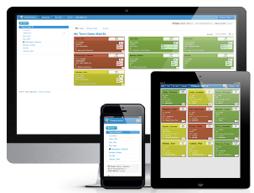

**Microcontroller**

Light Sensor

Send **SMS**

Humidity Sensor

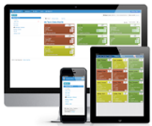



Standalone Application

Figure 25: System overview on rich picture

## 5.4 Summary

Technology is a key area that should select when developing a software project. So in this chapter it has been described about the technological perspective of the proposed software solution. In here it has been included the details about developing tools, Language to be used development infrastructures and also the technical and the usability requirements.

# Chapter 6

# Implementation & Testing

## 6.1 Introduction

This chapter will focus on the implementation of the proposed system. It illustrates about the program development, tools used and reason for selecting the language for the development. Furthermore testing procedures of the system will be discussed. This chapter covers about the physical implementation of the proposed system. The necessities that are required for the actual implementation of the developed system in the real environment are also been discussed in this report.

## 6.2 Program Development

The main task of the proposed solution is request management. And it is needed to reduce the complexity of the current system and build with user friendly system. When developing solution it’ll need more resources to follow programming process which will ensure high productivity in the end. When developing the system I have divided functions of the system into different modules and develop those modules separately in the aim of connecting those modules at the end.

Since the developed solution is sensor network based system so it needed to be select necessary language which ensures efficiency. For developed the proposed system developer used C#,arduino IDE as programming language. Moreover Online MIT app inventor used to design mobile application because it reduces the time to build the application because it uses the block architecture.

## 6.3 Implementation plan

In this section will describe how the virtual environment control system will be handover to clients. Software installation & configuration, error handling, user training etc., will be considered. This solution was developed to increase the efficiency of the prevailing visitor permission system.

### 6.3.1 Implementation tasks

I. Provide overall planning and coordination for the implementation

II. Provide appropriate training for personnel

III. Ensure that all manuals applicable to the implementation effort are available when needed

IV. Provide all needed technical assistance

V. Schedule any special computer processing required for the implementation

VI. Perform site surveys before implementation

VII. Ensure that all prerequisites have been fulfilled before the implementation date

VIII. Provide personnel for the implementation team

IX. Acquire special hardware or software

X. Perform data conversion before loading data into the system

## 6.4 System installation

After solution being developed and tested, it will be executed on real environment in client server scenario. When installing the system there are several approaches. They are,

I. Incremental implementation or phased approach

II. Parallel execution

III. One-time conversion and switchover

IV. Any combinations of the above

When selecting the approach need to be reviewed, then identify the advantages, disadvantages, risks, issues, estimated

### 6.4.1 Data conversion

In the data conversion process, researcher should convert data in the existing system to new system. In this case the project domain is currently using manual system data format. Data conversion is done after the system implementation

### 6.4.2 User training

All of the functionalities of the system totally depend on the data in the environment. Therefore users should be confidence with data entering. Other than that users should know about all the functionalities of the system in detail. User training will includes,

I. System hardware/software installation

II. System support

III. System maintenance and modification

## 6.5 Security and privacy

This project has the Login for the system for standalone application and the mobile application.It help to change data in the system from the unauthorized people.

## 6.6 Implementation support

This section of the Project Implementation Plan describes the support hardware, software, facilities, and materials required for the implementation, as well as the documentation, necessary personnel and training requirements, outstanding issues and implementation impacts to the current environment.

This hardware may include computers, servers as well as network and data communication requirement. Also include information about manufacturer support, licensing, and usage and ownership rights, and maintenance agreement details. If this information is need to record in another documents or system separate configuration plan and tools are needed.

Software includes list of non-hardware components like software, databases, OS, compilers, utilities etc.

## 6.7 Testing

Testing is a process of weighing a system components with the aim of finding whether it is satisfied the identified requirements or not. In simple term, testing is executing system in order to identify any gaps, errors or missing requirements in conflicting to the actual requirements.

|  |  |
| --- | --- |
| **Testing** | **Description** |
| Functionality testing | This technique is used to verify that there is no dead page or invalid redirects, checks all the validations on each fields, verify the workflow of the system and verify data integrity. |
| Usability testing | This verifies how the application is easy to use with. This performs navigation and control testing, content checking. |
| Compatibility testing | This performed based on the context of the application. This verifies application compatibility, operating system compatibility and the compatibility to various devices like notebook, mobile etc. |
| Unit testing | In this testing, testing will be done according to the unit wise, individual module are tested to determine whether there are any issues. It deal with the functional correctness of the standalone module. The main object of this is to separate each unit of the system to identify analyses and fix the defects |
| Component Testing | Each component will be tested to verify whether all component work correctly |
| System Testing | Whole system will be tested to check whether project is successful or not |

Table 2 :Testing techniques

## 6.8 Summary

This chapter focused on the implementation of the proposed system. It illustrated about the program development, tools used and reason for selecting the language for the development. Furthermore testing procedures of the system will be discussed. This chapter covered about the physical implementation of the proposed system. The necessities that are required for the actual implementation of the developed system in the real environment are also been discussed in this report.

# Chapter 7

# Evaluation

## 7.1 Introduction

Evaluation is taking to investigate the how the solution is able to manage the user requirement witch is gathered in initial phase. Other than that evaluation includes the assessment on the total project, details about the objectives achieved, and problems raised when total development and finally gathered knowledge will be discussed. Counter measures that have been taken to neutralize the issues will be deliberated.

## 7.2 Evaluation on the Project Development Process

When the system has been executed, the final phase in the project will be the use and assessment phase. In this phase, the system should be in full use to meet the objectives that were in the beginning recognized in the planning phase. Phases of the project are identified as the analysis, design and implementation.

### 7.2.1 Analysis Phase

In the analysis phase steering interviews, observations, going through existing documents to espoused methodologies. This stage play a critical role because the identified user requirement of this phase will be help to accomplish the system on time with less no of alterations after it was implemented.

### 7.2.1.1Practices of analysis stage

I. Fact finding

II. Recognizing limitations and issues in existing scenario.

III. Recognizing functional and non-functional requirements.

IV. Modelling the currents system with the help of flow charts, sequence diagrams, activity and class diagrams.

### 7.2.2 Design phase

In this stage the system design is prepared to fulfil the requirements identified in the analysis phase. System design document is prepared using the requirements witch exactly describes the design of system and this will be input to solution development in next stage.

#### 7.2.2.1 Practices of designing stage

* Design system using software and module architecture
* Design database and interfaces
* Develop prototype with several modules
* System module flow will be designed

#### 7.2.2.2 Assessing the designing phase

When building house the plan is the blue print of construction likewise system design is the blue print of system which is going to be developed. This phase is completed using wireframes, prototypes, software architecture, and module design of system. Software and Hardware architecture has been designed to give a clear picture about the components of the system. All the databases were initially designed at this phase. Interfaces were designed in order to develop the interface prototypes of the system. This phase will carry a massive amount of responsibility on constructing the system according to the specifications defined.

All the initial constructions for the testing and implementation phases of the system will be carried out during this phase.

### 7.2.3 Implementation phase

This phase is responsible for the coding the system according to the specifications defined in the earlier stage. All the coding, testing, implementation of the solution will be covered in this phase.

#### 7.2.3.1 Practices of implementation stage

I. Identifying testing approaches

II. Design of Test plan

III. Identifying major tasks on implementation

IV. Planning implementation

#### 7.2.3.2 Assessing the implementation phase

Total solution will be developed as separate components and they will be merge in the end of the project. Various testing is taking place during the integration of modules to ensure that the developed system to be error free. Maintaining the tasks of implementation let the implementation to flow steadily

## 7.3 Product evaluation

System evaluation is carried out to ensure the developed system fulfil the functional requirements, set by the clients other than that achievement of non-functional requirements of the system.

### 7.3.1 Methods of product evaluation

Interviews were conducted for that. Feedbacks about the system were recognize through those sessions. Solution was evaluated with all functionalities of developed system.

### 7.3.2 Evaluation Criteria

Evaluation measures how well the original ambitions of the new system (i.e. the logical design laid down during the analysis phase) have been achieved. Different systems will have different criteria that demonstrate their effectiveness or efficiency. Solution was evaluated using following measurements

* Functionality of the system
* User friendliness of the system
* Accuracy of the system
* Efficiency of the system
* Productivity of the system
* Compatibility of the system
* Flexibility

### 7.3.3 Problems which covers by the solution

* Avoid risk of greenhouse not being maintained at specific environmental conditions due to human Fault
* Customer can define specific greenhouse conditions and environment behavior
* Graph generation
* Automatically SMS Generation
* Plug-and play production

## 7.4 Project Achievement

Achievements made during the project are based on project’s aim, objectives and functional requirements and non-functional requirements.

### 7.4.1 Project Aim

The aim of this project is to build efficient and effective automated system to control the environment parameters that change rapidly.

### 7.3.2 Project Objectives

•Build best greenhouse which is equipped with automatic monitoring and controlling system

•Constantly monitor and control environmental condition in green house to ensure it at preset temperature light and humidity level.

•The user can see atmosphere condition of the greenhouse plant on standalone application and mobile application and control the green house from faraway places

•Minimizes labor costs involved in maintaining a greenhouse

•Detect and maintain temperatures.

## 7.4Summary

Evaluation is taking to investigate the how the solution is able to manage the user requirement witch is gathered in initial phase. Other than that evaluation includes the assessment on the total project, details about the objectives achieved, and problems raised when total development and finally gathered knowledge will be discussed. This chapter discussed the successfully of the whole system .Evaluation part check whether expected outcome meet or not. As well as it check whether user’s expected requirement satisficed or not

# 8.0 Conclusion

In this work, a design and implementation of greenhouse parameter and behaviors monitoring and control system has been proposed. This system has ability to collect the information about the main environmental parameters such as Temperature, Light, and Humidity and inside the greenhouse environment.Ths system has ability to keep these environment parameters smaller than the outside environment by using two fans. Environment parameters wirelessly are tram formed to central computer to proceed. Temperature, Humidity and Light Sensors are the four main sensors used in the project which give the exact value of temperature, Humidity and Light respectively. These sensors give the correct and accurate result according to the plant's condition. These results can be seen on the LCD screen present on the project and if environment parameter go beyond the entered value automatically SMS Notification is send to the User's mobile phone.

# 10.0 Reference

[1] I. F. Akyildiz, W. Su, Y. Sankarasubramaniam, and E. Cayirci, “Wireless sensor networks: a survey,” *Comput. Netw.*, vol. 38, no. 4, pp. 393–422, 2002.

[2] Y. Song, C. Gong, Y. Feng, J. Ma, and X. Zhang, “Design of greenhouse control system based on wireless sensor networks and AVR microcontroller,” *J. Netw.*, vol. 6, no. 12, pp. 1668–1674, 2011.

[3] R. H. Hussain, A. F. Marhoon, and M. T. Rashid, “Wireless Monitor and Control System for Greenhouse,” *Int. J. Comput. Sci. Mob. Comput.*, vol. 2, no. 12, pp. 69–87, 2013.

[4] T. Ahonen, R. Virrankoski, and M. Elmusrati, “Greenhouse monitoring with wireless sensor network,” in *Mechtronic and Embedded Systems and Applications, 2008. MESA 2008. IEEE/ASME International Conference on*, 2008, pp. 403–408.

[5] C. Yawut and S. Kilaso, “A wireless sensor network for weather and disaster alarm systems,” in *Proc. International Conference on Information and Electronics Engineering, IPCSIT*, 2011, vol. 6.

[6] M. A. Perillo and W. B. Heinzelman, “Wireless sensor network protocols,” *Algorithms Protoc. Wirel. Mob. Netw. Eds Boukerche Al CRC Hall Publ.*, 2004.

[7] M. Nakamura, A. Sakurai, and J. Nakamura, “Distributed Environment Control Using Wireless Sensor/Actuator Networks for Lighting Applications,” *Sensors*, vol. 9, no. 11, pp. 8593–8609, Oct. 2009.

[8]Y. Song, C. Gong, Y. Feng, J. Ma, and X. Zhang, “Design of greenhouse control system based on wireless sensor networks and AVR microcontroller,” J. Netw., vol. 6, no. 12, pp. 1668–1674, 2011.

[9]R. H. Hussain, A. F. Marhoon, and M. T. Rashid, “Wireless Monitor and Control System for Greenhouse,” Int. J. Comput. Sci. Mob. Comput., vol. 2, no. 12, pp. 69–87, 2013.

[10]T. Ahonen, R. Virrankoski, and M. Elmusrati, “Greenhouse monitoring with wireless sensor network,” in Mechtronic and Embedded Systems and Applications, 2008. MESA 2008. IEEE/ASME International Conference on, 2008, pp. 403–408.

[11]C. Yawut and S. Kilaso, “A wireless sensor network for weather and disaster alarm systems,” in Proc. International Conference on Information and Electronics Engineering, IPCSIT, 2011, vol. 6.

[12]M. A. Perillo and W. B. Heinzelman, “Wireless sensor network protocols,” Algorithms Protoc. Wirel. Mob. Netw. Eds Boukerche Al CRC Hall Publ., 2004.

[13]M. Nakamura, A. Sakurai, and J. Nakamura, “Distributed Environment Control Using Wireless Sensor/Actuator Networks for Lighting Applications,” Sensors, vol. 9, no. 11, pp. 8593–8609, Oct. 2009.

# Appendix

1. Login

For use the system everyone must need to login to system by using this window.



Figure 26:Login Window

After login to the system you can see the Control interface .This is the main interface of the system.



Figure 27:Main interface

In this above interface user can control the whole project. There are four main section. Two section can be used to control our base station. According following panelist can be used to control output device automatically or manually. If you tick Auto system will automatically control the output devices. If you tick Manual Radio button, User can control the output devices automatically. User can switch on the light, fan and switch off the light, fan. As well as user can control the output devices as Low, medium and high.

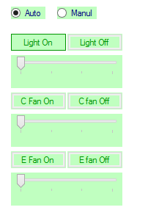

Figure 28: Auto manual Panel

Figure 28 is the control panel. User can enter the Temperature, Humidity and Light value that must be in the green house. If Environment parameters exceed or reduce automatically output devices will be activated

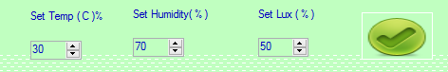

Figure 29: Control Panel

Figure 28 show the Current environment parameters values .User can see these value From it user can get good decision about the environment

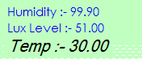

Figure 30:Details Panel

2.Mobile Application

This is the Mobile application as standalone application user can log on to the system.Using control window user can control the output devices manually. This mobile application for only manual purposes.

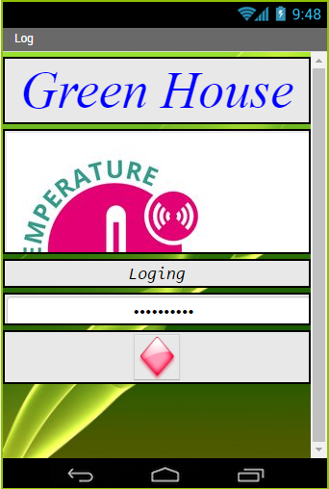

Figure 31:Login window of mobile application

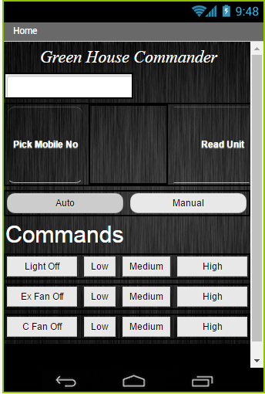

Figure 32: Control Window

Using this control window user can control output devices from far away. User can read the environment parameters value from anywhere .According to that values user can control the Base station.

3.Arduino Programming Code

#include <EEPROM.h>

#include <LiquidCrystal_I2C.h>

LiquidCrystal_I2C lcd(0x27, 2, 1, 0, 4, 5, 6, 7, 3, POSITIVE); // Set the LCD I2C address

#include <Wire.h>

#include <dht.h>

#include <SoftwareSerial.h>

#define DHT21_A_PIN A0

#define e_fan 9

#define c_fan 10

#define light 11

byte count = 0;

bool mod = 1;

dht DHT_A;

SoftwareSerial mySerial(3, 2); // RX, TX

unsigned long mil = 0;

bool flag = 0;

String data, roll;

float te, hu, lux = 0;

byte def_temp = 31, def_hu = 90, def_lux = 30;

bool t_flag = 0, h_flag, l_flag = 0;

bool li_ok, c_ok, e_ok;

long li_count = 0, c_count = 0, e_count = 0;

void setup() {

Serial.begin(9600);

mySerial.begin(9600);

Serial.println("Strat");

pinMode(e_fan, OUTPUT);

pinMode(c_fan, OUTPUT);

pinMode(light, OUTPUT);

digitalWrite(e_fan, LOW);

digitalWrite(c_fan, LOW);

digitalWrite(light, LOW);

lcd.begin(16, 2);

lcd.setCursor(0, 0);

lcd.print("Starting...");

delay(2000);

lcd.setCursor(0, 1);

lcd.print("Waiting for PC");

lcd.setCursor(0, 1);

delay(2000);

char ack;

while (mySerial.find("1") <= 0 ) {

mySerial.println("2");

}

lcd.clear();

lcd.print("Connected");

delay(2000);

Serial.println("AT");

delay(500);

Serial.println("AT+CNMI=2,2,0,0,0");

delay(500);

Serial.println("AT+CMGF=1\r");

delay(500);

delay(100);

dht();

lux = analogRead(A1);

lux = map(lux, 0, 1024, 0, 100);

}

void loop() {

tym();

// ;

if (mySerial.available()) {

char c = mySerial.read();

if (c == '\n') {

chk();

//Serial.println(data);

data = "";

}

else {

data += c;

}

}

if (Serial.available()) {

char c = Serial.read();

//Serial.print(c);

if (c == '\n') {

chk();

//Serial.println(data);

data = "";

}

else {

data += c;

}

}

if (mod == 1) {

lux = analogRead(A1);

lux = map(lux, 0, 1024, 0, 100);

if (lux < def_lux) {

analogWrite(light, map(lux, 0, def_lux, 255.00, 0.00));

li_ok = 1;

}

else {

analogWrite(light, 0);

li_ok = 0;

}

double te_val = te - def_temp;

if (te_val >= 0 && te_val < 6) {

te_val = te_val / 5.0 * 255.0;

analogWrite(c_fan, te_val);

c_ok = 1;

}

else if (te_val <= 0) {

analogWrite(c_fan, 0);

c_ok = 0;

}

else if (te_val > 5) {

analogWrite(c_fan, 255);

c_ok = 1;

}

double hu_val = hu - def_hu;

if (hu_val >= 0 && hu_val < 6) {

hu_val = hu_val / 5.0 * 255.0;

analogWrite(e_fan, hu_val);

e_ok = 1;

}

else if (hu_val < 0) {

analogWrite(e_fan, 0);

e_ok = 0;

}

else if (hu_val > 5) {

analogWrite(e_fan, 255);

e_ok = 1;

}

}

if (flag) {

dht();

sms_contrl();

flag = 0;

lux = analogRead(A1);

lux = map(lux, 0, 1024, 0, 100);

lcd.clear();

lcd.setCursor(0, 0);

lcd.print("Hu ");

lcd.print(hu);

lcd.print("%");

lcd.setCursor(0, 1);

lcd.print("Tmp ");

lcd.print(te);

lcd.print("C");

lcd.setCursor(15, 1);

if (mod) {

lcd.print("A");

}

else

lcd.print("M");

lcd.setCursor(10, 0);

lcd.print("Lux");

lcd.print(int(lux));

lcd.print("%");

count++;

if (count == 1) {

mySerial.print("L");

mySerial.println(lux);

}

if (count == 2) {

mySerial.print("H");

mySerial.println(hu);

}

if (count == 3) {

mySerial.print("T");

mySerial.println(te);

count = 0;

}

}

}

//***************************************************************************************************

void sms_contrl() {

if (c_ok == 1 && t_flag == 0 && mod == 1 && c_count > 30) {

roll = "Temp increase. Turn on the Cooling Fan\n";

sms();

t_flag = 1;

c_count = 0;

}

if (c_ok == 0 && t_flag == 1) {

t_flag = 0;

}

if (e_ok == 1 && h_flag == 0 && mod == 1 && e_count > 30) {

roll = "Humidity increase. Turn on the Exhaust Fan\n";

sms();

h_flag = 1;

e_count = 0;

}

if (e_ok == 0 && h_flag == 1) {

h_flag = 0;

}

if (li_ok == 1 && l_flag == 0 && mod == 1 && li_count > 30) {

roll = "Light level goes low. Turn on the Light\n";

sms();

l_flag = 1;

li_count = 0;

}

if (li_ok == 0 && l_flag == 1 && mod == 1) {

l_flag = 0;

}

}

//****************************************************************************************************

void chk() {

if (data.startsWith("T")) {

def_temp = data.substring(1).toInt();

EEPROM.update(0, def_temp);

lcd.clear();

lcd.setCursor(0, 0);

lcd.print("Temp floating");

lcd.setCursor(0, 1);

lcd.print(" set to ");

lcd.print(def_temp);

delay(1000);

}

else if (data.startsWith("H")) {

def_hu = data.substring(1).toInt();

EEPROM.update(1, def_hu);

lcd.clear();

lcd.setCursor(0, 0);

lcd.print("Hu floating");

lcd.setCursor(0, 1);

lcd.print(" set to ");

lcd.print(def_hu);

delay(1000);

}

else if (data.startsWith("L")) {

def_lux = data.substring(1).toInt();

EEPROM.update(2, def_lux);

lcd.clear();

lcd.setCursor(0, 0);

lcd.print("Lux floating");

lcd.setCursor(0, 1);

lcd.print(" set to ");

lcd.print(def_lux);

delay(1000);

/* lcd.clear();

lcd.setCursor(0, 0);

lcd.print("T ");

lcd.print(def_temp);

lcd.setCursor(6, 0);

lcd.print("H");

lcd.print(def_hu);

lcd.setCursor(12, 0);

lcd.print("T");

lcd.print(def_lux);

lcd.setCursor(0, 1);

lcd.print("data Saved");

delay(1000);*/

}

else if (data.indexOf("readunit") >= 0 ) {

roll = "Reply from unit \n";

sms();

}

// Serial.println(data.indexOf("cfoff"));

if (data.indexOf("cfoff") >= 0 && mod == 0) {

digitalWrite(c_fan, LOW);

// Serial.println("c_on");

lcd.clear();

lcd.setCursor(0, 0);

lcd.print("Cooling Fan off");

delay(1000);

}

else if (data.indexOf("cflow") >= 0 && mod == 0) {

analogWrite(c_fan, 50);

// Serial.println("c_on");

lcd.clear();

lcd.setCursor(0, 0);

lcd.print("Cooling Fan low");

delay(1000);

}

else if (data.indexOf("cfmid") >= 0 && mod == 0) {

analogWrite(c_fan, 100);

// Serial.println("c_on");

lcd.clear();

lcd.setCursor(0, 0);

lcd.print("Cooling Fan mid");

delay(1000);

}

else if (data.indexOf("cfhi") >= 0 && mod == 0) {

analogWrite(c_fan, 255);

// Serial.println("c_on");

lcd.clear();

lcd.setCursor(0, 0);

lcd.print("Cooling Fan high");

delay(1000);

}

//*******************************************************************

if (data.indexOf("efoff") >= 0) {

digitalWrite(e_fan, LOW);

//Serial.println("e_on");

lcd.clear();

lcd.setCursor(0, 0);

lcd.print("Exhaust Fan off");

delay(1000);

}

else if (data.indexOf("eflow") >= 0) {

analogWrite(e_fan, 50);

//Serial.println("e_on");

lcd.clear();

lcd.setCursor(0, 0);

lcd.print("Exhaust Fan low");

delay(1000);

}

else if (data.indexOf("efmid") >= 0) {

analogWrite(e_fan, 100);

//Serial.println("e_on");

lcd.clear();

lcd.setCursor(0, 0);

lcd.print("Exhaust Fan mid");

delay(1000);

}

else if (data.indexOf("efhi") >= 0) {

analogWrite(e_fan, 255);

//Serial.println("e_on");

lcd.clear();

lcd.setCursor(0, 0);

lcd.print("Exhaust Fan high");

delay(1000);

}

//*************************************************************

if (data.indexOf("lioff") >= 0 && mod == 0) {

digitalWrite(light, LOW);

// Serial.println("e_off");

lcd.clear();

lcd.setCursor(0, 0);

lcd.print("Light off");

delay(1000);

}

else if (data.indexOf("lilow") >= 0 && mod == 0) {

analogWrite(light, 50);

// Serial.println("e_off");

lcd.clear();

lcd.setCursor(0, 0);

lcd.print("Light low");

delay(1000);

}

else if (data.indexOf("limid") >= 0 && mod == 0) {

analogWrite(light, 100);

// Serial.println("e_off");

lcd.clear();

lcd.setCursor(0, 0);

lcd.print("Light mid");

delay(1000);

}

else if (data.indexOf("lihi") >= 0 && mod == 0) {

analogWrite(light, 255);

// Serial.println("e_off");

lcd.clear();

lcd.setCursor(0, 0);

lcd.print("Light hi");

delay(1000);

}

if (data.indexOf("auto") >= 0) {

mod = 1;

// Serial.println("e_off");

lcd.clear();

lcd.setCursor(0, 0);

lcd.print("Auto Mode");

lcd.setCursor(0, 1);

lcd.print(" actived..");

delay(1000);

}

else if (data.indexOf("manu") >= 0) {

mod = 0;

// Serial.println("e_off");

lcd.clear();

lcd.setCursor(0, 0);

lcd.print("Manual Mode");

lcd.setCursor(0, 1);

lcd.print(" actived..");

delay(1000);

}

}

//******************************************************************************************

void sms() {

lcd.clear();

lcd.print("Sensding sms...");

String msg_body = roll;

msg_body += "\nTemp = ";

msg_body += String(te);

msg_body += "C \nHumidity = ";

msg_body += String(hu);

msg_body += "% \nLux Level =";

msg_body += String(lux);

msg_body += "% ";

Serial.println("AT");

delay(500);

Serial.println("AT+CMGF=1");

delay(500);

// Serial.println("AT+CMGS=\"+94717424602\"");

Serial.println("AT+CMGS=\"+94715701413\"");

delay(500);

Serial.println(msg_body);

delay(500);

delay(500);

lcd.clear();

lcd.print("Sent..");

delay(1000);

}

//**************************************************************************************

void tym() {

if (millis() - mil > 500) {

flag = 1;

mil = millis();

li_count++;

if (li_count > 100) {

li_count = 100;

}

c_count++;

if (c_count > 100) {

c_count = 100;

}

e_count++;

if (e_count > 100) {

e_count = 100;

}

}

}

//******************************************************************************************

void dht() {

int chk = DHT_A.read21(DHT21_A_PIN);

te = DHT_A.temperature, 1;

hu = DHT_A.humidity, 1;

}